Teacher Notes

Inquiry Question
- What makes a good number system?

Curricular Connections
Learning Standards
- I can engage in problem-solving experiences that are connected to other cultures
- I can develop, demonstrate, and apply mathematical understanding through play, inquiry, and problem-solving
- I can connect mathematical concepts to each other and to other areas

Lesson Sequence

Page Number in this guide | Lesson outline
p. 3 | Introduction Activity  - This gets student thinking started about number systems, even though most will not think about what makes a good number system. Students can use their creativity to make whatever number system they fancy, to be revised and improved upon in later lessons.
p. 4-10 | Number systems across cultures  - Students examine patterns found in number systems across culture and history
n/a | What makes a good number system?  - After examining number systems of various cultures, students can work in groups to brainstorm and discuss what makes a good number system  - They can also examine the first number system they made and discuss advantages and disadvantages
n/a | Watch TED-Ed Video https://www.youtube.com/watch?v=cZH0YnFpjwU  - Discuss key ideas from the video: 1) positional notation 2) importance of zero 3) base 10 vs other bases
p. 11 | Read “History of Counting” by Denise Schmandt-Besserat  - Discuss guided reading questions
p. 12-15 | Number System Inquiry Project  - Students revise and improve upon their original number system, to create an original and efficient number system, based on criteria discussed in class
p. 16 | Gallery Walk  - Students view their classmates’ number systems and try to write out certain numbers using their number system  - They may even vote on the best one – the one that’s most efficient and original

Project Differentiation Strategies

Content differentiation
- In the process of examining number systems from different cultures, various levels of math concepts could be discussed or omitted depending on the readiness of the students. In order of difficulty (from least to greatest), concepts that could be discussed in the following order:
  - Patterning (patterns that are found in various number systems)
  - Zero (importance as a number and as a placeholder)
  - Place value and positional notation (using the same symbols to represent different quantities depending on the placement of those symbols)
  - Base 10 (making groups of 10) vs. other bases
- The number systems from various cultures also vary in levels of difficulty. Some or all of the number systems could be examined depending on the readiness of students. Number systems, in order of difficulty (from least to greatest) are listed below:
  - Arabic and Hindu (same as our number system, but uses different symbols)
  - Egyptian and Greek (simple repeating patterns)
  - Roman (more complex pattern with both addition and subtraction)
  - Mayan and Babylonian (uses base 20 and base 60)
- For the project itself, the amount of content could also be modified or omitted depending on the readiness of students. The project contents, in order of difficulty (from least to greatest) are listed below:
  - Representing whole numbers up to 1000
  - Operations with numbers (adding, subtracting, multiplying, dividing)
  - Representing fractions
  - Representing negative numbers

Product differentiation
- Students can choose the format in which they will present their final project. Students who enjoy hands-on projects could create a poster or booklet. Those who enjoy using technology could create a PowerPoint or digital poster. Others who feel that their strength is in verbal output could use iMovie or Explain Everything to create videos with them introducing and explaining their number system.

Introduction Activity Name: _________

You have founded a new land called _____________________ and as the new ruler, you get to create your own number system! Write down symbols you would use for your number system below:

1= | 9= | 17=
2= | 10= | 18=
3= | 11= | 19=
4= | 12= | 20=
5= | 13= | 30=
6= | 14= | 99=
7= | 15= | 100=
8= | 16= | 0=

Number Systems Across Cultures

Learning intention: I can engage in problem-solving experiences that are connected to place, story, cultural practices, and perspectives relevant to other cultures

Number System | How would you describe the pattern of their number system? | Using the symbols of the number system, how would you write…
 |  | 60 | 85 | 99
Egyptian
Babylonian
Roman
Greek
Arabic
Hindu
Maya
Number Systems Across Cultures ANSWER KEY

Learning intention: I can engage in problem-solving experiences that are connected to place, story, cultural practices, and perspectives relevant to other cultures

Number System | How would you describe the pattern of their number system? | Using the symbols of the number system, how would you write…
 |  | 60 | 85 | 98
Egyptian | - Base 10 system  - Different symbols are used for each power of 10  - Symbols are repeated to indicate addition of the same quantity |  | IIIII | IIIII III
Babylonian | - Base 60 system  - Positional notation used (symbols mean different numbers depending on placement) – eg. one and sixty use the same symbol  - Zero is not used as placeholder | 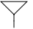  Babylonians had a base 60 system, and did not have a symbol for zero. As a result, 60 looks exactly like 1 (just like how our 10 would look like 1 if there was no zero) | 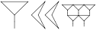 | 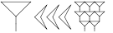
Roman | - Base 10 system  - If a letter is written after another letter of greater value, then the values are added  - If a letter is written before another letter of greater value, then the smaller value is subtracted from the greater value | LX | LXXXV | XCVIII
Greek | - Base 10 system  - Different symbols are used for each number up to 10, each multiple of 10 up to 100, and each multiple of 100 etc. | ξ’ | ’ | ’
Arabic | - Base 10 system  - Positional notation – placement of the symbols changes their value  - Zero is used as a number and placeholder
Hindu | - Base 10 system  - Positional notation – placement of the symbols changes their value  - Zero is used as a number and placeholder
Maya | - Base 20 system  - The eye symbol is zero, and is used as both number and placeholder  - Positional notation – placement of the symbols changes their value (eg. dot is 1 if in the bottom row; 20 if in the top row)
Number Systems Across Cultures
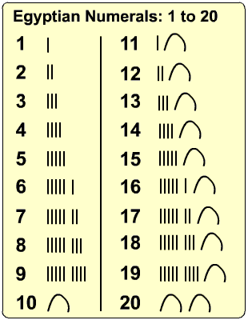

Babylonian Numbers
61= | 62= | 63= | 64= | 65=
70= | 80= | 90= | 100= | 101=

Roman Numerals
1 | I | 21 | XXI | 41 | XLI | 61 | LXI | 81 | LXXXI
2 | II | 22 | XXII | 42 | XLII | 62 | LXII | 82 | LXXXII
3 | III | 23 | XXIII | 43 | XLIII | 63 | LXIII | 83 | LXXXIII
4 | IV | 24 | XXIV | 44 | XLIV | 64 | LXIV | 84 | LXXXIV
5 | V | 25 | XXV | 45 | XLV | 65 | LXV | 85 | ?
6 | VI | 26 | XXVI | 46 | XLVI | 66 | LXVI | 86 | LXXXVI
7 | VII | 27 | XXVII | 47 | XLVII | 67 | LXVII | 87 | LXXXVII
8 | VIII | 28 | XXVIII | 48 | XLVIII | 68 | LXVIII | 88 | LXXXVIII
9 | IX | 29 | XXIX | 49 | XLIX | 69 | LXIX | 89 | LXXXIX
10 | X | 30 | XXX | 50 | L | 70 | LXX | 90 | XC
11 | XI | 31 | XXXI | 51 | LI | 71 | LXXI | 91 | XCI
12 | XII | 32 | XXXII | 52 | LII | 72 | LXXII | 92 | XCII
13 | XIII | 33 | XXXIII | 53 | LIII | 73 | LXXIII | 93 | XCIII
14 | XIV | 34 | XXXIV | 54 | LIV | 74 | LXXIV | 94 | XCIV
15 | XV | 35 | XXXV | 55 | LV | 75 | LXXV | 95 | XCV
16 | XVI | 36 | XXXVI | 56 | LVI | 76 | LXXVI | 96 | XCVI
17 | XVII | 37 | XXXVII | 57 | LVII | 77 | LXXVII | 97 | XCVII
18 | XVIII | 38 | XXXVIII | 58 | LVIII | 78 | LXXVIII | 98 | ?
19 | XIX | 39 | XXXIX | 59 | LIX | 79 | LXXIX | 99 | XCIX
20 | XX | 40 | XL | 60 | ? | 80 | LXXX | 100 | C

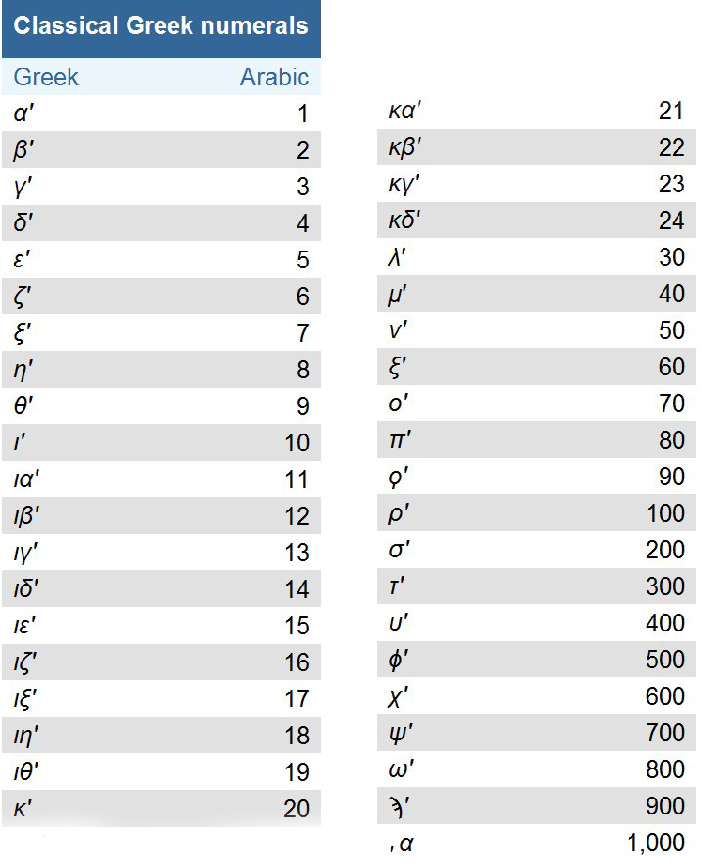

Mayan Numbers
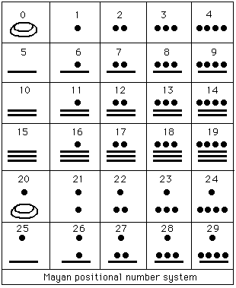
30 | 40 | 50 | 100

Guided Reading Questions
The History of Counting by Denise Schmandt-Besserat

Page | Question
7 | How would your life be different without counting?  - We would not be able to keep track of the date, how much money we have, how fast we are driving, etc.
8 | What does it mean to count without numbers?  - Using same number of corresponding items to represent quantities (eg. pebbles to represent coconuts)
10 | What is body counting?  - Using parts of body to represent numbers
12 | What is counting concretely?  - Using different numbers/words to count different categories of things (eg. twins, duo)
14 | What is abstract counting?  - Separating the number from the object being counted (using the same numbers for different types of objects)
20 | Why did it take so long to invent abstract numbers?  - People had no need for abstract counting or counting of large numbers previously
26 | What number were the Sumerians missing and why was this important?  - Zero – this means they had no place holder number and could confuse 54 and 504
34-36 | What are some advantages of the Arabic numeral system?  - Each of the 10 digits had its own symbol (no need to repeat 1 three times to make 3 eg. III)  - The digits can be combined to create infinitely large numbers without having to invent new symbols  - Names of numbers are combinations of digits, so there’s less words to remember (eg. twenty-nine, ninety-seven)  - The place value system allows the same digits to represent different quantities (Eg. 5 in 54 represents 50; 5 in 5983 represents 5000)  - Zero is used as a placeholder to make place value more clear  In your opinion, what is the biggest advantage of the Arabic numeral system?

Number System Inquiry Project Name: _____________

Learning Intentions
- I can engage in problem-solving experiences that are connected to other cultures
- I can develop, demonstrate, and apply mathematical understanding through play, inquiry, and problem-solving
- I can connect mathematical concepts to each other and to other areas

Project Description
Now that you have examined some number systems across various cultures and thought about what makes a good number system, modify or recreate your original number system to make it better. You will also need to think and write about the advantages and disadvantages of your number system. You can present your number system in a manner of your choice (eg. Poster, PowerPoint, booklet).

Project Content
- Show enough whole numbers from 0-1000 so that someone else will be able to see the pattern and write any number from 0 to 1000 in your number system
- Show 3 examples of negative numbers (gr. 7’s only)
- Using your numbers, show 2 examples each of:
  - Adding
  - Subtracting
  - Multiplying
  - Dividing
- Show 3 examples of how your number system would represent parts of a whole
- Explain at least 3 advantages of your number system (why it’s a good number system)
- Explain any disadvantages of your number system
- Compare and contrast your number system with one other number system in history (not our current number system)

Criteria | Not Yet Meeting | Approaching | Meeting | Exceeding
Number system includes required components (whole numbers, 4 operations, parts of wholes, negatives) | Many components are missing | Number system is missing some components | Number system includes all components listed | Number system includes all components listed plus additional types of numbers
Number system is logical and efficient to use | Number system has many inefficiencies or is not logical in its patterns | Number system has some inefficiency (eg. when representing very large numbers or doing operations) | Number system is similar in logic and efficiency to our current number system | Number system is logical, efficient to use, and improves upon our current system by using a more effective base
Presentation is clear, organized, and easy to follow | Disorganized and unclear | Some disorganization or lack of clarity | Clear and visually organized | Thoughtfully presented in a clear and visually engaging manner
Advantages and disadvantages of your number system are explained | Not explained | Missing clarity or detail | With clarity and detail | With clarity, detail and insight
Project Planning Template

Name of your Number System: _____________________________________________

Whole Numbers

2 examples each of adding, subtracting, multiplying, dividing using your number system

3 examples of representing parts of a whole

3 examples of negative numbers (grade 7’s only)

Explain at least 3 advantages of your number system

1. ___________________________________________________________________________________
__________________________________________________________________________________________________________________________________________________________________________
_____________________________________________________________________________________
_____________________________________________________________________________________
_____________________________________________________________________________________

2. ___________________________________________________________________________________
_____________________________________________________________________________________
_____________________________________________________________________________________
_____________________________________________________________________________________
_____________________________________________________________________________________
_____________________________________________________________________________________

3. ___________________________________________________________________________________
_____________________________________________________________________________________
_____________________________________________________________________________________
_____________________________________________________________________________________
_____________________________________________________________________________________
_____________________________________________________________________________________

Explain any disadvantages of your number system

_____________________________________________________________________________________
_____________________________________________________________________________________
_____________________________________________________________________________________
_____________________________________________________________________________________
_____________________________________________________________________________________
_____________________________________________________________________________________

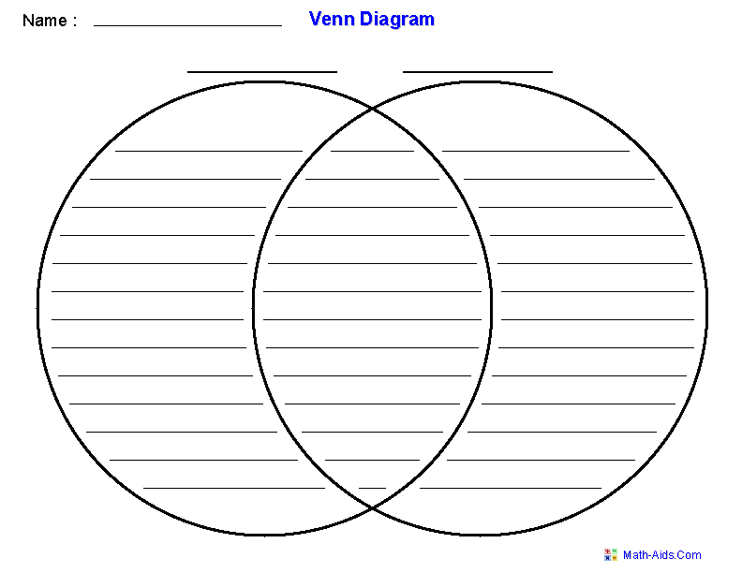

Write down similarities and differences between your number system and another number system in history (not our current number system).

Number Systems Gallery Walk Name: _________

Examine your classmates’ number systems and see if you can become an expert.

Name of classmate | Using the symbols of their number system, how would you write…
 | 99 | 247 | 508 | 900 | 9/10

